Screenshots of the project : -

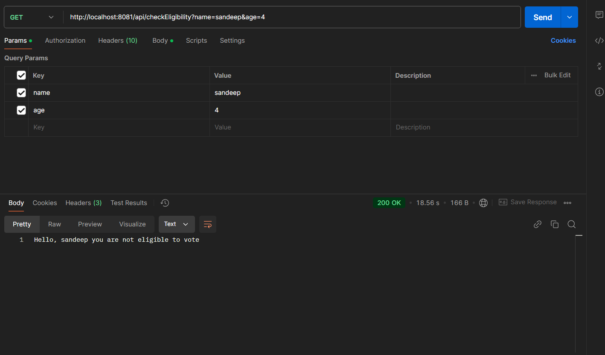

Diagram 1. Not eligible to vote

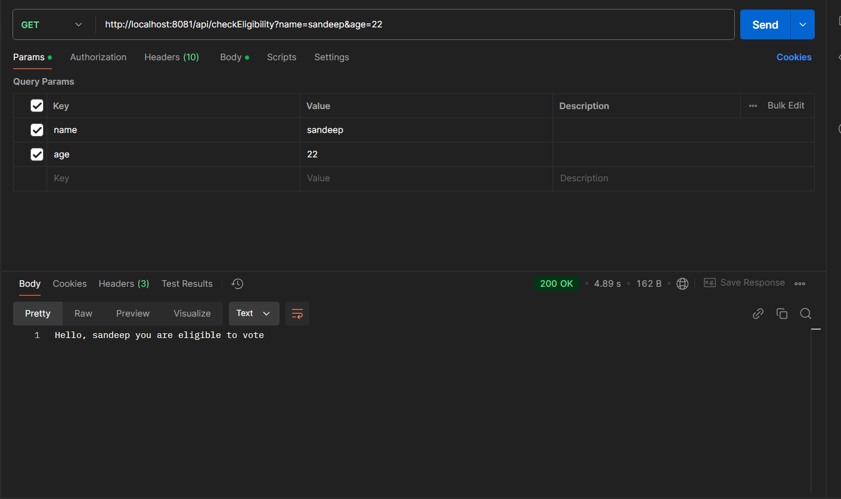

Diagram 2. Eligible to vote



Diagram 3. Age not passed in params



Diagram 4. Name not passed in params

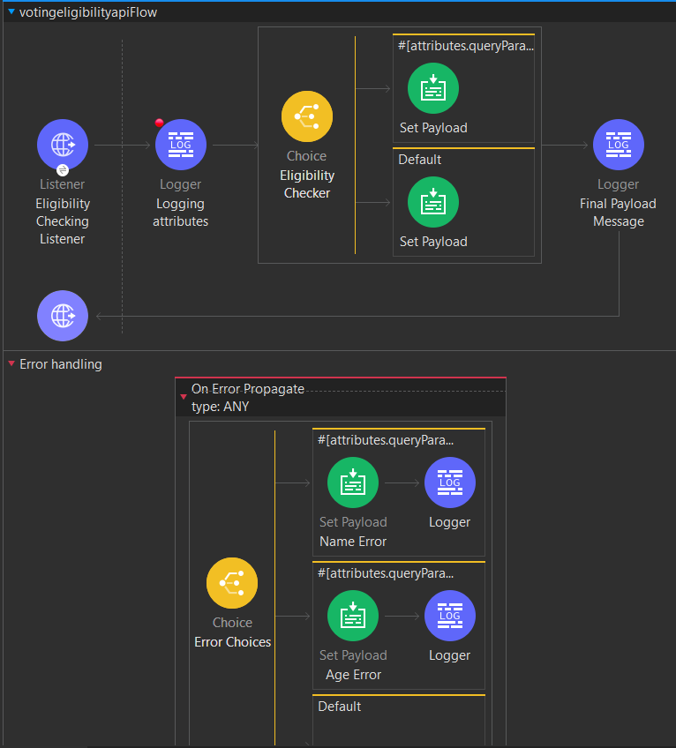

Diagram 5. Flow Representation

Link to the public endpoint :- <https://votingeligibilityapi-9d1f0v.5sc6y6-3.usa-e2.cloudhub.io>

API ROUTE :- /api/checkEligibility

Parameter :- name , age

Example : - https://votingeligibilityapi-9d1f0v.5sc6y6-3.usa-e2.cloudhub.io/api/checkEligibility?age=25&name=Sandeep